SQ3 Name: Class Serial Number:
- Derive the expression for 3-phase apparent power in terms of symmetrical components.
- Find the y parameters of the network shown in Fig. 1. R = 6 Ω.
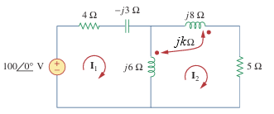
- Write the mesh equations for the for the circuit shown in Fig.2. k = 1.2
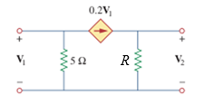
Fig. 2
Fig. 1

